Microsoft Digital Literacy
Productivity Software
Test Item File Answer Key

Lesson 2: Common Features and Commands

Objective 2.1 Identify the main components of the user interface.

1. Markus creates a document by using Microsoft® Office Word 2003 and saves it with the name Office.doc.

Which of the following components of Word 2003 will display the document name?

A. Menu bar
B. Toolbar
C. Title bar (Correct Answer)
D. Status bar

2. Cornelia uses Microsoft Office Excel 2003 to create a worksheet that contains the estimated costs of her business project. She wants to update certain costs.

Which component of Excel 2003 will display the changes in the worksheet?

A. Title bar
B. Work area (Correct Answer)
C. Scroll bar
D. Task bar

Objective 2.2 Identify the purpose of the commands on the menu bar.

3. Stephan creates a business presentation by using Microsoft Office PowerPoint 2003. He saves it with the name Presentation.ppt. Stephan opens the file to make some changes, and he wants to save it with a different name.

Which of the following commands on the File menu will Stephan use to save the file with a different name?

A. Save
B. Save As (Correct Answer)
C. Send To
D. Page Setup

4. Nina uses Excel 2003 to create a work plan for her team. She wants to print the plan and discuss it with the team members in a meeting.

Which of the following menus will Nina use to print the plan?

A. File (Correct Answer)
B. View
C. Format
D. Tools

5. You use Office Word 2003 to create a business document. You copy text from another document and want to add it to your business document.

Which of the following commands on the Edit menu will you use for this?

A. Paste (Correct Answer)
B. Replace
C. Go To
D. Find

6. Ewa creates a table by using Word 2003 to record some data. She wants to increase the size of the text in the table to make it more readable.

Which command on the Format menu will Ewa use to change the size of the text in the table?

A. Font (Correct Answer)
B. Paragraph
C. AutoFormat
D. Columns

Objective 2.4 Work with the pointer in a program.

7. You use Office Word 2003 to write an essay about uses of computers. After typing the document, you notice that a few words have a red wavy underline as shown in the exhibit.

Using the mouse, which action will you perform to view the shortcut menu for the underlined words?

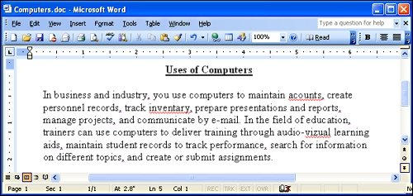

A. Right-click (Correct Answer)
B. Double-click
C. Click
D. Scroll

8. You want to send an e-mail message to your friend to describe your meeting with Michal. However, you incorrectly type the name as Michael.

Where will you place the insertion point if you want to use the DELETE key to remove the letter e in the name Michael?

A. After the letter l
B. Before the letter l
C. Before the letter e (Correct Answer)
D. After the letter e

Objective 2.5 Work with text and characters in a program.

9. You want to access your MSN® Hotmail® account to check e-mail messages. The characters in your password are in upper case.

Which key will you press on the keyboard to type the password correctly in upper case?

A. NUM LOCK
B. CAPS LOCK (Correct Answer)
C. INSERT
D. CTRL

10. You create a document in which you forget to include an important line in a paragraph. When you type the missing text, you begin to overwrite the existing text.

Which key do you press on the keyboard to ensure that the new text does not overwrite the existing text in the paragraph?

A. INSERT (Correct Answer)
B. BACKSPACE
C. SPACEBAR
D. ENTER

Objective 2.6 Explain the use of primary keyboard shortcuts and key combinations.

11. You create a business presentation by using Office PowerPoint 2003.

Which key will you use as a shortcut to display a slide show in PowerPoint 2003?

A. F5 (Correct Answer)
B. F6
C. F7
D. F8

12. You are at the tenth page of a 20-page document. You need to make changes on the last page of the document.

Which key will you use in combination with CTRL to move to the bottom of the last page?

A. ESC
B. SHIFT
C. HOME
D. END (Correct Answer)

13. Peter wants to protect a confidential document by using a password. He wants to use an asterisk and an ampersand symbol in his password.

Which of the following keys does he press in combination with the number keys to correctly type the symbols in his password?

A. SHIFT (Correct Answer)
B. INSERT
C. SPACEBAR
D. BACKSPACE

14. You create a document by using Office Word 2003. You need to enter the copyright symbol in this document.

Which key combination will you use to add the copyright symbol?

A. ALT+0169 (Correct Answer)
B. TAB+0169
C. INSERT+0169
D. SHIFT+0169

Lesson 3: Word Processors

Objective 3.1: Perform basic tasks in a word processor.

15. Anna is learning how to use a word processor. She wants to know the various tasks that she can perform by using this program.

Which of the following options will answer her question? Select four.

A. Create documents (Correct Answer)
B. Edit videos
C. Host a Web site
D. Format text (Correct Answer)
E. Edit documents (Correct Answer)
F. Print pages (Correct Answer)
G. Perform real-time communication

16. Your friend sees you working on Microsoft® Office Word 2003. He wants to know how to start this program.

Arrange the steps in the following list in the order in which you will perform them to start Word.
Steps:
- Click Start.
- Point to Microsoft Office.
- Point to All Programs.
- Click Microsoft Office Word 2003.

Correct Order:
A. Click Start.
C. Point to All Programs.
B. Point to Microsoft Office.
D. Click Microsoft Office Word 2003.

17. Waleed creates a 100-page document. He wants to review the document from the beginning. He does not want to scroll up, but he wants to reach the beginning of the document by using the shortest method.

Which of the following keys will he use?

A. CTRL+UP ARROW
B. HOME
C. CTRL+HOME (Correct Answer)
D. UP ARROW

Objective 3.2: Edit and format text

18. Christa makes a list of the guests she wants to invite to her daughter's wedding. She types the guest names and contact details in a document in Office Word 2003. She wants to know how many guests are on the list.

Which of the following features will help Christa track the number of guests while she makes the list?

A. Bullets and Numbering (Correct Answer)
B. AutoFormat
C. Reviewing
D. Word Count

19. Your friend wants to move text from the first paragraph of an article to the last paragraph by using the quickest method.

Which of the following options will help him do this?

A. Delete the text from the first paragraph and then type it in the last paragraph.
B. Use the Cut command to delete the text from the first paragraph, and then paste it in the last paragraph. (Correct Answer)
C. Type the text of the first paragraph in the last paragraph and then delete it from the first paragraph.
D. Enter the text of the first paragraph in a new document.

Objective 3.3: Work with tables and pictures.

20. Tony creates a table by using Office Word 2003. He wants to shade some cells in a row. He selects the cells and now wants to know how to shade them.

Arrange the steps in the following list in the order in which Tony will perform them to shade the cells.

Steps:
- Click Borders And Shading.
- In the Borders And Shading box, click the Shading tab.
- Click OK.
- Click the Format menu.
- Select a color.

Correct Order:
D. Click the Format menu.
A. Click Borders And Shading.
B. In the Borders And Shading box, click the Shading tab.
E. Select a color.
C. Click OK.

21. Jim wants to insert the logo of his company at the top of a document in Word 2003. The logo is saved in the My Pictures folder.

Arrange the steps in the following list in the order in which Jim will perform them to insert the logo from the My Pictures folder.
Steps:
- Click the Insert menu.
- Select the file that contains the logo image.
- Place the pointer where the logo should be inserted.
- Click From File.
- Click the Insert button.
- Point to Picture.

Correct Order:
C. Place the pointer where the logo should be inserted.
A. Click the Insert menu.
F. Point to Picture.
D. Click From File.
B. Select the file that contains the logo image.
E. Click the Insert button.

22. Karim uses Word 2003 to create a table that lists his expenses for January and February, as shown in the exhibit. He also wants to include his transportation expenses for January and February.

What will he do to include in the table the information about his transportation expenses?

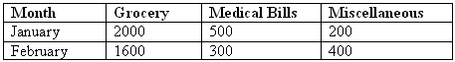

A. Add a column. (Correct Answer)
B. Insert a row.
C. Add a cell.
D. Modify the paper size.

23. Isabel wants to write an essay in Spanish by using Office Word 2003. She wants to use the language tools for Spanish, such as the spelling checker that Word provides.

Which of the following menus will she use to set the language to Spanish so that she can use the language tools for Spanish?

A. Tools (Correct Answer)
B. View
C. Format
D. Insert

24. Daniela creates a document by using Office Word 2003, as shown in the exhibit. She uses the Spelling and Grammar tool to detect a misspelled word.

Which of the following buttons will Daniela use to correct the spelling of this word throughout the document?

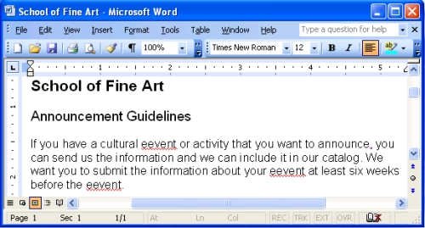

A. Change All (Correct Answer)
B. Accept Change
C. AutoFormat
D. Track Changes

25. Your friend wants to know about the AutoCorrect feature of Word 2003.
What will you tell her about the AutoCorrect feature?

A. It helps you define the formatting attributes in a document.
B. It identifies spelling errors while you type and suggests alternatives for them. (Correct Answer)
C. It formats the styles of the text.
D. It enables you to set default paper margins.

Objective 3.4: Identify the various benefits offered by Desktop Publishing (DTP).

26. Barbara wants to create a newsletter. She needs a program that provides several newsletter templates.

Which of the following programs will meet her needs?

A. Desktop publishing program (Correct Answer)
B. Presentation program
C. E-mail program
D. Spreadsheet program

27. David wants to know the benefits of desktop publishing programs.

Which of the following benefits do desktop publishing programs provide? Select Two.

A. Advanced formatting techniques (Correct Answer)
B. Control for longer documents (Correct Answer)
C. Video editing
D. Virus scanning
E. Web site browsing

Lesson 4: Spreadsheets

Objective 4.1 Identify the components of a spreadsheet.

28. Syed wants to know how to properly refer to the intersection of a row and a column in a spreadsheet.

Which of the following options answers his question?

A. Cell (Correct Answer)
B. Label
C. Value
D. Worksheet

29. Richard creates his monthly budget on a worksheet in Microsoft® Office Excel 2003. He enters data in the worksheet, as displayed in the exhibit.

What is the collection of cells containing the data called?

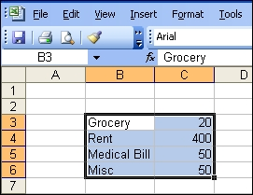

A. Cell range (Correct Answer)
B. Row
C. Column
D. Cell pointer

30. Charlotte creates her expense sheet for the month, as shown in the exhibit.

Which column will she use to enter the amount spent on fuel?

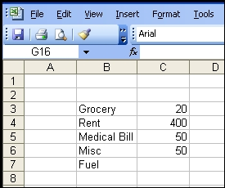

A. B
B. C (Correct Answer)
C. 7
D. 8

Objective 4.2: Enter data into a spreadsheet.

31. Your friend sees you working in Excel 2003 and wants to know how to start this program.

Arrange the steps in the following list in the order in which you will perform them to start Excel.
Steps:
- Click Start.
- Point to Microsoft Office.
- Point to All Programs.
- Click Microsoft Office Excel 2003.

Correct Order:
A. Click Start.
C. Point to All Programs.
B. Point to Microsoft Office.
D. Click Microsoft Office Excel 2003.

32. Oliver plans to buy some household items. He lists all the household items and their expected prices in a worksheet in Excel 2003. He wants to sort all of the items by price, in ascending order.

Arrange the steps in the following list in the order in which Oliver will perform them to sort the items in the budget.

Steps:
- On the toolbar, click Data.
- Select the cell range that needs to be sorted.
- Click Ascending.
- Open the worksheet.
- Click Sort.
- Click OK.

Correct Order:
D. Open the worksheet.
B. Select the cell range that needs to be sorted.
A. On the toolbar, click Data.
E. Click Sort.
C. Click Ascending.
F. Click OK.

33. John creates budget sheets for his project by using Office Excel 2003. He wants to replace the name of the current budget sheet with another name.

Arrange the steps in the following list in the order in which John will perform them to rename the worksheet.

Steps:
- Press ENTER.
- Type the new name.
- Select the worksheet that needs to be renamed.
- Double-click the worksheet tab.

Correct Order:
C. Select the worksheet that needs to be renamed.
D. Double-click the worksheet tab.
B. Type the new name.
A. Press ENTER.

Objective 4.3 Perform basic mathematical tasks in a spreadsheet.

34. Alexander lends some money to Niraj. Alexander maintains a worksheet that lists the amount and the date when he lent money to Niraj, as displayed in the exhibit. He wants to calculate the total amount of money he lent to Niraj. The list is very long, and he wants to know if there is a button that he can click to calculate the total amount due.

Which of the following toolbar buttons will Alexander click?

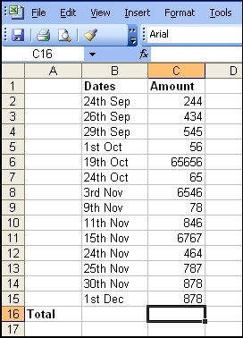

A. AutoSum (Correct Answer)
B. AutoCorrect
C. AutoSummarize
D. AutoFormat

35. Erik receives his report card and wants to calculate his average marks. The exhibit displays the worksheet that Erik created.

Identify the formula that Erik will use to calculate the average.

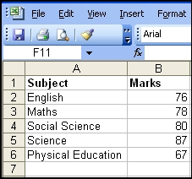

A. =AVERAGE(A2:A6)
B. =AVERAGE(B2:B6) (Correct Answer)
C. =AVERAGE(A6:B6)
D. =AVERAGE(A2:B6)

36. Vladimir borrows some money from Victor and then returns some of the amount to Victor the next day. Vladimir wants to know how much money he still owes to Victor. He maintains all of the records in a worksheet, as displayed in the exhibit.

Which of the following formulas will Vladimir use?

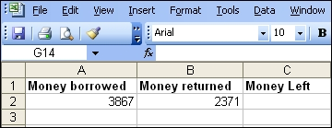

A. =Sub(A2,B2)
B. =A2-B2 (Correct Answer)
C. =Minus(A2-B2)
D. =Sub(A2-B2)

37. David wants to copy all the files from his office computer to his laptop. To prepare, he calculates the total size of the files he needs to copy. The files and their sizes are displayed in the exhibit. David wants to enter the formula in a cell to calculate this sum.

Arrange the steps in the following list in the order in which David will perform them.

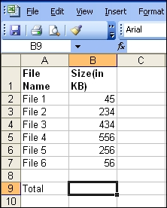

Steps:
- In the Select A Function list, select SUM.
- Select the cell range.
- Open the Insert menu.
- Click OK.
- Click Function.
- Click OK.

Correct Order:
C. Open the Insert menu.
E. Click Function.
A. In the Select A Function list, select SUM.
D. Click OK.
B. Select the cell range.
F. Click OK.

38. David uses Office Excel 2003 to calculate his average marks. He enters a formula in cell B5 to calculate the average based on the values in cells B2 to B4, as displayed in the exhibit. David realizes that he entered his Science score as 67 instead of 69.

What will cell B5 display if he changes the value in cell B4 to 69?

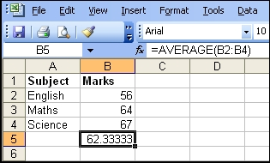

A. Updated average (Correct Answer)
B. Blank cell
C. Error message
D. #DIV/0!

Objective 4.4 Insert charts and graphs in a spreadsheet.

39. Dina plans her budget. She wants to know what part of the total expenses she spent on groceries last month. She uses a spreadsheet and wants to make a chart to depict the portion spent on the groceries.

Which of the following charts will meet her needs?

A. Line
B. Pie (Correct Answer)
C. Surface
D. Area

40. Marko uses Excel 2003 to create a budget sheet for the total expenses that he spends on household items. He wants to view the data in a graph.

Which tool will he use to represent the data through a graph?

A. Chart Wizard (Correct Answer)
B. AutoContent Wizard
C. Clip art gallery
D. Budget Template Wizard

41. Patrik wants to show his household expenses through a pie chart. He wants to know the method to insert a pie chart in a worksheet in Excel 2003.

Arrange the steps in the following list in the sequence that will help Patrik to insert the chart.

Steps:
- In the Insert menu, click Chart.
- In the Chart type box, click Pie.
- Select the cell range.
- Click Finish.

Correct Order:
C. Select the cell range.
A. In the Insert menu, click Chart.
B. In the Chart Type box, click Pie.
D. Click Finish.

Lesson 5: Presentation Programs

Objective 5.1 Identify the basic functionalities offered by presentation programs.

42. Your friend sees you working on a presentation program. She wants to know about the features of this program.

Identify the features of presentation programs. Select two.

A. Create audio-visual presentations (Correct Answer)
B. Create handouts (Correct Answer)
C. Edit video
D. Perform calculations
E. Enable real-time communication

Objective 5.2 Create a presentation.

43. David uses Microsoft® Office PowerPoint® 2003 to create a presentation. He wants to add more slides to the presentation.

Which of the following menus will he use to add slides to the presentation?

A. Insert (Correct Answer)
B. Tools
C. Edit
D. File

44. Carol is learning to create a presentation by using PowerPoint 2003. She wants to know how to add display effects on various slides of the presentation.

Which of the following options will you suggest to her?

A. Slide Design
B. Slide Transition (Correct Answer)
C. Slide Show
D. Slide Layout

45. Pia creates a presentation by using PowerPoint. The slides in the presentation must contain a title, a bulleted list, and a diagram.

Which of the following menu options will she select to do this?

A. Chart Wizard
B. Slide Transition
C. Background
D. Slide Layout (Correct Answer)

Objective 5.3 Add graphics and multimedia into a presentation.

46. You create a presentation by using Office PowerPoint 2003.You open the Insert menu to add a sound file to a slide.

Arrange the following steps in the order in which you will perform them to add a sound file to the slide. Place the first step at the top of the list.

Steps:
- Click OK.
- Point to Movies And Sounds.
- Select the audio file that you want to add.
- Click Sound From File.

Steps in Correct Order:
B. Point to Movies And Sounds.
D. Click Sound From File.
C. Select the audio file that you want to add.
A. Click OK.

47. You create a presentation by using PowerPoint.

Which of the following toolbars will you use to add geometric shapes to the presentation?

A. Drawing (Correct Answer)
B. Formatting
C. Reviewing
D. Standard

48. Laura opens a presentation that she creates by using PowerPoint 2003. She wants to manually set timings for a slide show. Therefore, she wants to view the slides in the presentation as thumbnails.

Which of the following views will Laura choose?

A. Outline
B. Slide Sorter (Correct Answer)
C. Normal
D. Slide Show

49. Stella uses PowerPoint to create a presentation about the performance of her class. In the presentation, she wants to show a comparison between the assessment scores of her class in the current year and the previous year.

Which of the following objects will Stella add to the presentation to display the comparison?

A. AutoShape
B. Video clips
C. Clip Art
D. Chart (Correct Answer)

50. You use PowerPoint 2003 to prepare a presentation about the quarterly performance of your organization across various regions. You represent this graphically by adding a Line chart in your presentation. However, you want to change the Line chart to a Column chart. To do this, you double-click the chart to display the Chart menu.

Which of the following Chart menu commands will you use to change the Line chart to a Column chart?

A. Chart Type (Correct Answer)
B. Chart Options
C. AutoFormat
D. AutoCorrect

Objective 5.4 Identify the various options available to print presentations in different formats.

51. You create a presentation by using PowerPoint. You include examples in the presentation for your reference, as shown in the exhibit. You need to print the presentation to take it home.

Which of the following options will you select in the Print box to ensure that the examples are also printed?

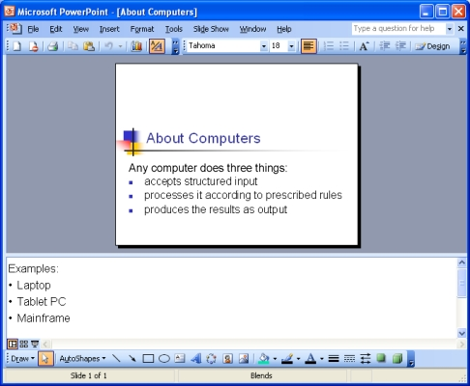

A. Notes Pages (Correct Answer)
B. Slides
C. Handouts
D. Outline View

52. Larry prepares a presentation by using PowerPoint 2003. He needs to print the presentation to keep the key points handy. He wants an overview of the text in the slides, and he does not want to print the graphics.

Which of the following formats will Larry select in the Print box to print the presentation?

A. Notes Pages
B. Slides
C. Handouts
D. Outline View (Correct Answer)
Lesson 6: Databases

Objective 6.1 Explain basic database concepts.

53. Paula manages the recruitments for A. Datum Corporation. The company hires 500 employees. Paula needs to store on her computer the personal details, compensation structure, and insurance details for each employee.

Which of the following programs will Paula use?

A. Microsoft® Notepad
B. Photo editing program
C. Presentation program
D. Database program (Correct Answer)

54. Raman is a school administrator. He wants to store the records of all the students on his computer. He wants to maintain a database of all the records.

Which of the following objects can he create by using a database program? Select three.

A. Reports (Correct Answer)
B. Forms (Correct Answer)
C. Tables (Correct Answer)
D. Video clips
E. Presentations
F. Pictures

55. Michelle is a teacher at the School of Fine Art. She wants to start Microsoft Office Access 2003 to update the student database by entering details about the students in her class.

Arrange the steps in the following list in the order in which Michelle will perform them to start Access on her computer.

Steps:
- Point to All Programs.
- Click Microsoft Office Access 2003.
- Point to Microsoft Office.
- Click Start.

Steps in Correct Order:
D. Click Start.
A. Point to All Programs.
C. Point to Microsoft Office.
B. Click Microsoft Office Access 2003.

56. Ken creates a database in Access and saves it on his computer. He wants to open this database to view some details.

Arrange the steps in the following list in the order in which Ken will perform them to open the database.

Steps:
- In the File menu, click Open.
- In the folder, double-click the database file.
- In the Database window, click Open.
- Select the folder where the file is saved.
- In the Database window, click the object that you want to open.

Steps in Correct Order:
A. In the File menu, click Open.
D. Select the folder where the file is saved.
B. In the folder, double-click the database file.
E. In the Database window, click the object that you want to open.
C. In the Database window, click Open.

Objective 6.2 Create a database.

57. You create a table in the employee database of your company. You want the employee codes to be unique.

Which of the following actions will you perform on the Employee Code field in the database table?

A. Define the field as a primary key. (Correct Answer)
B. Specify the data type as text.
C. Set a Validation Rule for the field.
D. Create an Input Mask for the field.

58. Stephanie wants to create a new table in Access.

Which of the following options will she use?

A. Write a macro.
B. Use a wizard. (Correct Answer)
C. Create a form.
D. Generate a report.

59. Larry creates a table by using Access. He wants to set data types for the fields in the table.

In which of the following views will Larry open the table to set the data types?

A. Datasheet view
B. Design view (Correct Answer)
C. Print preview
D. Table Wizard

60. Mark is a librarian at the School of Fine Art. By using Access 2003, he wants to create a database of the available books and their authors.

Which of the following menus will Mark use to create this database?

A. Tools
B. File (Correct Answer)
C. Database Objects
D. Database Utilities

Objective 6.3 Work with records in a database.

61. You work with Contoso, Ltd. Jesper is a newly hired manager in your company. You want to include his personal details in the employee database table.

Which of the following actions will you perform to include Jesper's details in the table?

A. Add a record in the table. (Correct Answer)
B. Add a field in the table.
C. Apply a filter to the database.
D. Generate a report by using the table.

62. Karim is a shopkeeper. Every day he needs to check the quantity of available items in his shop. To easily maintain the records and get the updated inventory details, he creates a table in Access. Which of the following data types will Karim use to enter the quantity of each item?

A. Text
B. Number (Correct Answer)
C. Memo
D. AutoNumber

63. You create a table in Access. You want to view the names in the table in alphabetical order.

Which of the following actions will you perform on the Name field?

A. Set up Validation Rule.
B. Set up a Format.
C. Sort in ascending order. (Correct Answer)
D. Create a query.

Objective 6.4 Explain what database queries are and how they work

64. You open a table in Access in Datasheet view. You want to filter the data in the table.

Which of the following menus will you use to select the filter command?

A. Tools
B. Record (Correct Answer)
C. Format
D. Insert

65. Richard joins your team. You ask him to update the office database. He wants to know what a database query is.

What will you tell Richard?

A. A question that retrieves data, based on the criteria you specify (Correct Answer)
B. A program that produces a printed report of the data in the database
C. A program that simplifies data entry
D. An object that updates the operating system

Objective 6.5 Explain what reports are and their uses.

66. Daniel needs to work with databases frequently. He wants to learn about database reports.

For which of the following purposes can he use the reports? Select two.

A. Organize data (Correct Answer)
B. Summarize data (Correct Answer)
C. Enter data
D. Search data
E. Modify data

